**COMP4910 Senior Design Project 1, Fall 2018**

**Advisor: Mehmet Ufuk Çağlayan**

**AGATE: A Web Based Business System**

**Requirements Specifications Document**

**26.11.2018**

**Revision 1.0**

**By: Mehmet Uzunkavakaltındayataruyuroğlu**

**Student ID Number: 123456789**

# Revision History

|  |  |  |
| --- | --- | --- |
| **Revision** | **Date** | **Explanation** |
| 1.0 | 26.11.2018 | Initial requirements |

# Contents

Revision History 2

Contents 3

1. Introduction to Agate 4

2. Existing Computer Systems 5

3. Business Activities in the Current System 6

4. Summary of Requirements 7

5. References 7

# 1. Introduction to Agate

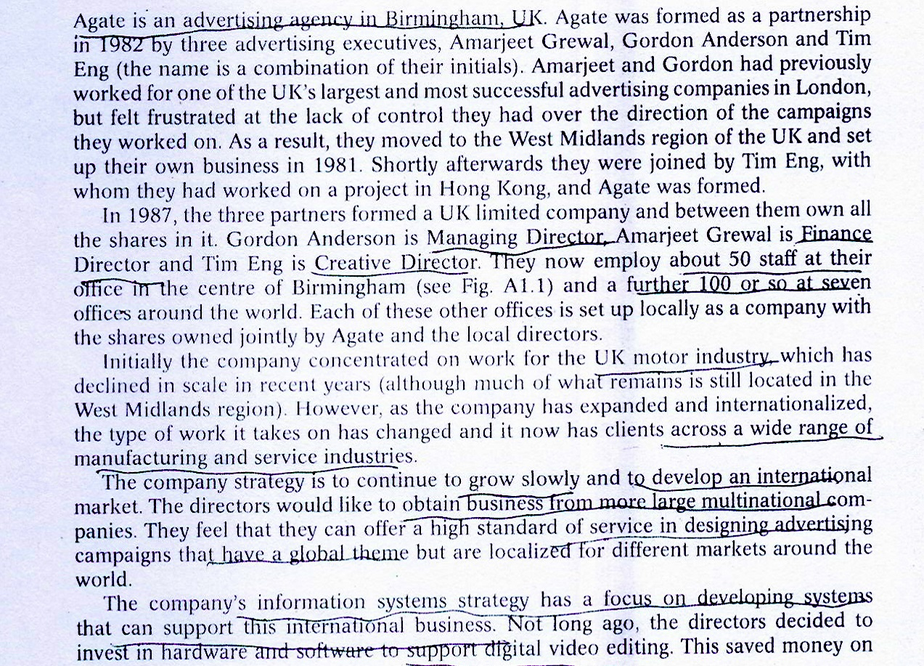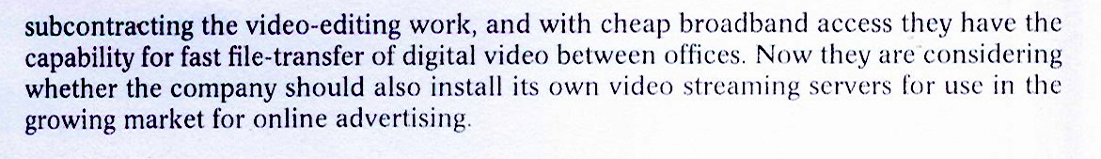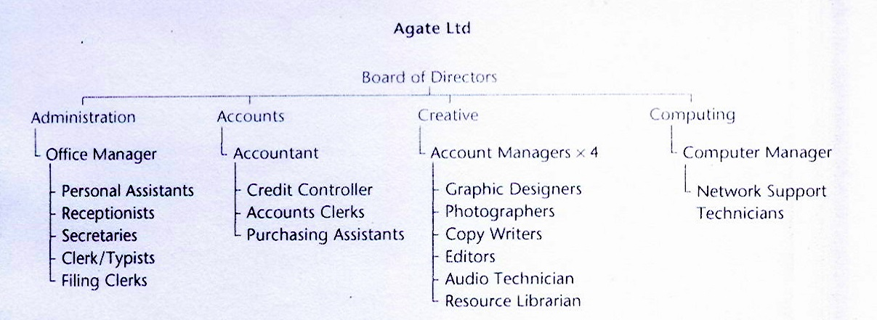

Fig. 1.1. Staff at Agate LTD. UK Office

# 2. Existing Computer Systems

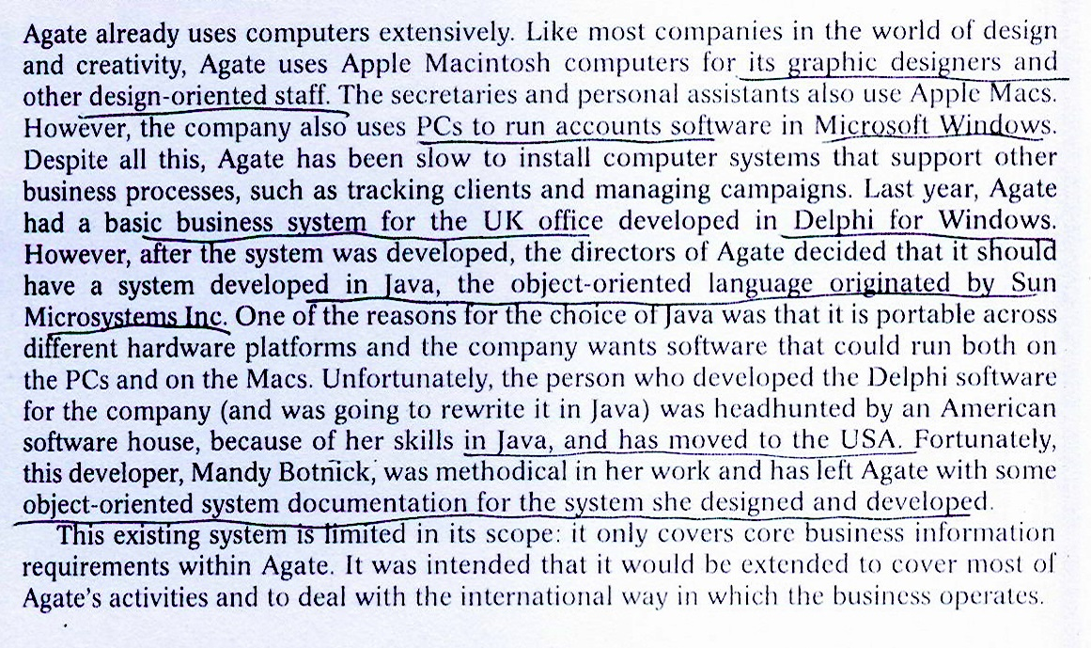

# 3. Business Activities in the Current System



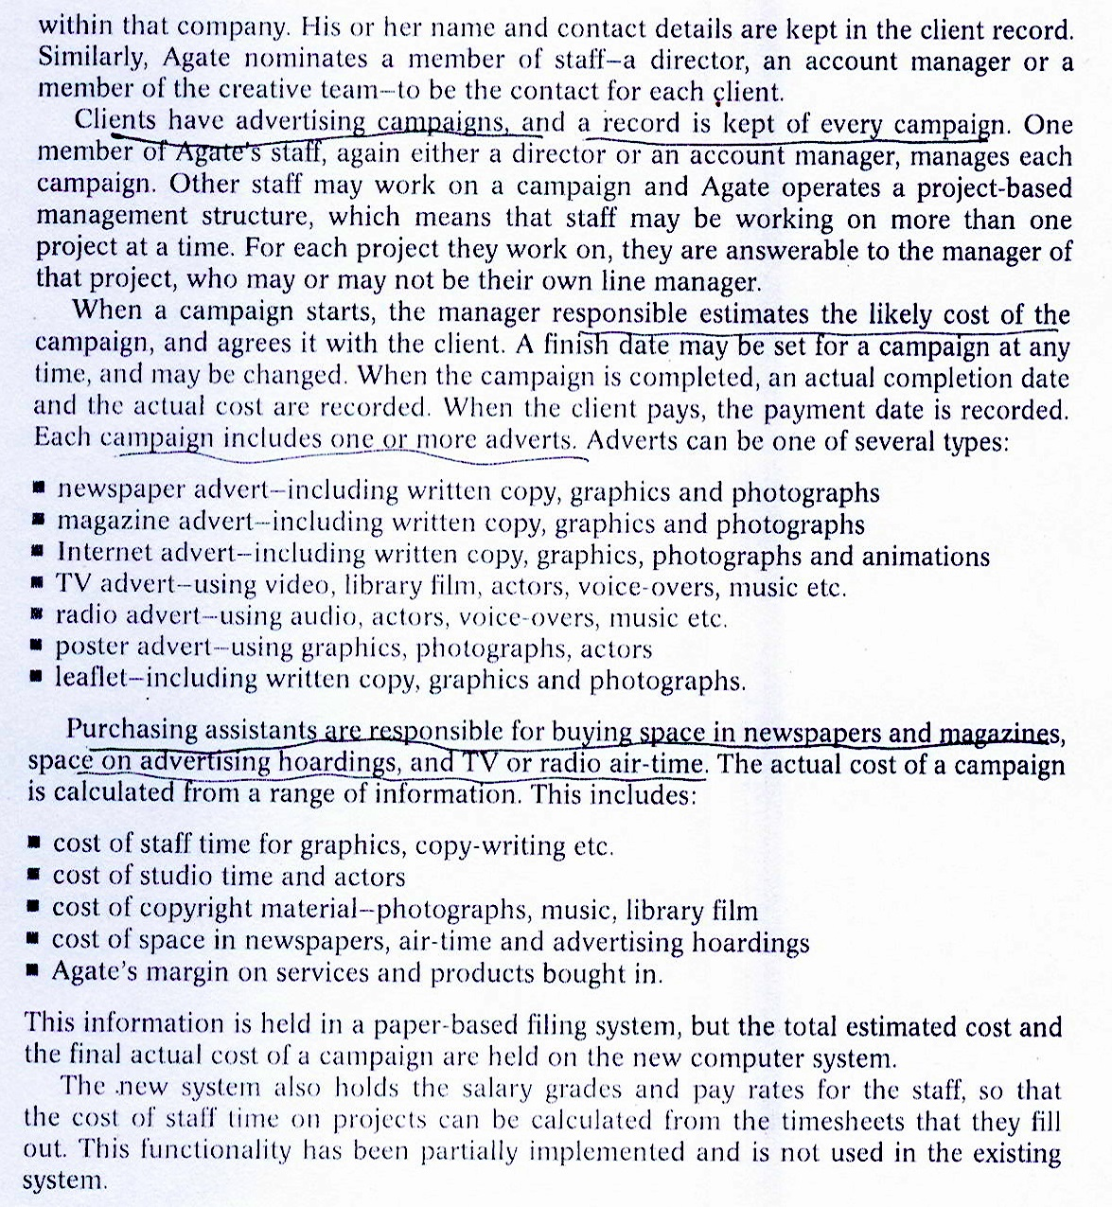

# 4. Summary of Requirements

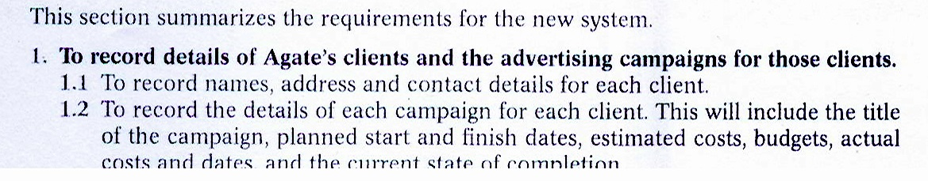

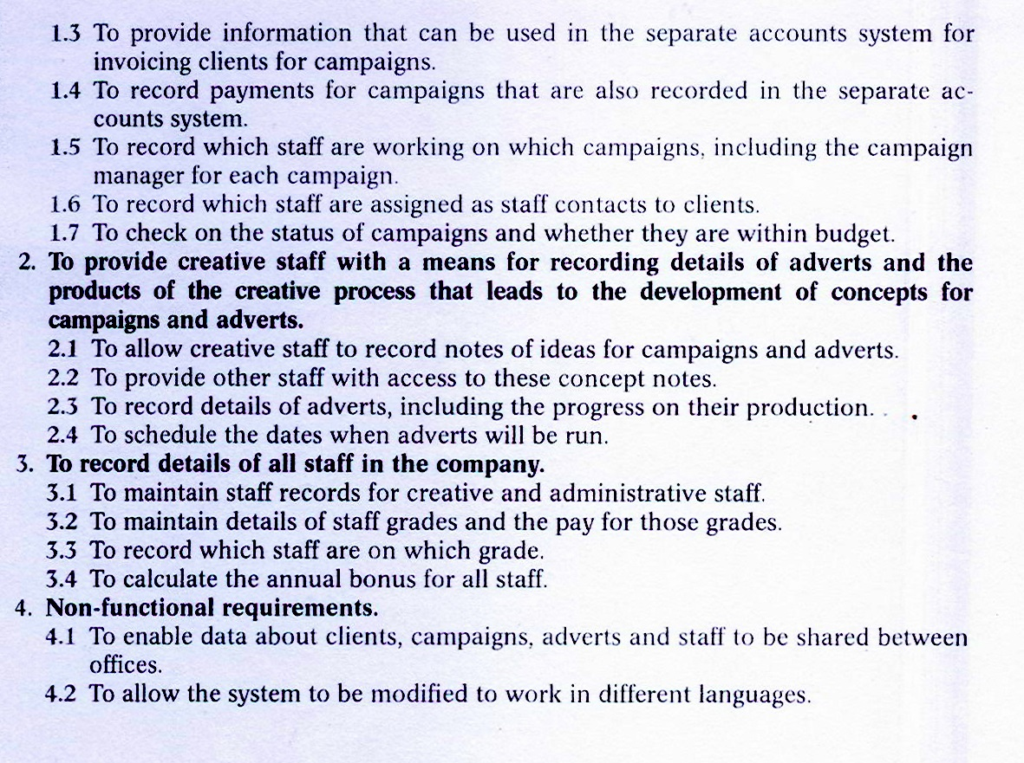

# 5. References

1. For Agate Case Study, see: Bennett, McRobb, Farmer, Object Oriented Systems Analysis and Design Using UML, McGraw-Hill, 2010, 4th Edition.
2. R. S. Pressman, Software Engineering: A Practitioner’s Approach, McGraw Hill, 7th Edition, 2010.